**INTAN SURAYA BINTI LOKMAN** 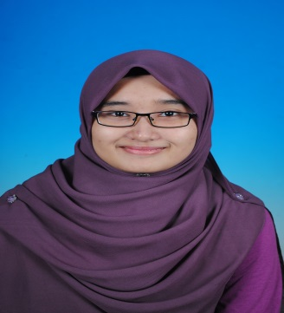

**Permanent Address :**

No 6, Jalan Selat Selatan ½,

Taman Selat Damai, Pandamaran,

42000 Pelabuhan Klang,

Selangor Darul Ehsan.

**Tel :** 012-3408578

**E-mail :** [surayalokman@yahoo.com.my](mailto:surayalokman@yahoo.com.my)

**Personal Particulars :**

**Age :** 22 years old

**Date of Birth :** 28th March 1994

**IC No. :** 940328-10-5640

**Nationality :** Malaysia

**Gender :** Female

**Marital Status:** Single

**CAREER OBJECTIVES**

Seeking an internship place in corporate administrative where I can utilize my knowledge and gain experience as well as to gain self-development and motivation of the organization.

**EDUCATIONS**

|  |
| --- |
| **SEPT 2015 – PRESENT** Universiti Teknologi Mara (UiTM), Campus Seremban  Bachelor in Corporate Administration  With CGPA 3.02 |
| **DEC 2012 – APRIL 2015** Universiti Teknologi Mara (UiTM), Campus Seremban  Diploma in Public Administration  With CGPA 3.08 |
| **JAN 2007 – DEC 2011** Sekolah Menengah Kebangsaan (P) Raja Zarina  Sijil Pelajaran Malaysia (SPM) |

**EXPERIENCES**

|  |
| --- |
| **EDUWIS EDUCATION SDN BHD – Part Time Teacher ( June 2012 – September 2012)**   * Experience job as a part-time teacher for Eduwis Education Port Klang Branch * Teach student from 4 years old - 6 years old for English and Science subject |

**SOCIAL PARTICIPATIONS**

|  |
| --- |
| * Social Marketing Exhibition (2015) – AJK Program |

**STRENGTH & SKILL**

|  |  |
| --- | --- |
| **Personal Characteristics:** | * Hardworking * Self-organized and high in self confidence * Ability to work individually and as a team member * Fast learner - willing and always ready to learn new things |
| **Communication Skills:** | * Excellent in Bahasa Malaysia * Good in English |
| **Written Skills:** | * Bahasa Malaysia and English |
| **Software:** | * Microsoft Software – Words, Powerpoint, Excel |

**REFERENCES**

Mohd Faiz Ismail Prof. Madya Norhayati Mohd Salleh

Coordinator AM225 Deputy Dean

Practical Training Faculty of Administration Science & PolicyStudies

Universiti Teknologi Mara (UiTM) Universiti Teknologi Mara (UiTM)

Kampus Seremban 3, Negeri Sembilan Kampus Seremban 3, Negeri Sembilan

H/P : 012-2370020 H/P : 019-6273755

Office : 06-6342914 Office : 06-6342114

Email : [faiez@ns.uitm.edu.my](mailto:faiez@ns.uitm.edu.my) Email : [noran@ns.uitm.edu.my](mailto:noran@ns.uitm.edu.my)